Question 1:

* Use Pan-Tompkins algorithm to process the ECG data
* Show every step’s output
* Find the heart rate

MATLAB CODE:  
load('SADAT_ECG_II-L06.mat');

x1 = data;

y=length(x1);

fs = 200;

N = length (x1);

t = [0:N-1]/fs;

figure(1)

subplot(2,1,1)

plot(t,x1)

subplot(2,1,2)

plot(t(200:600),x1(200:600))

xlim([1 3])

x1 = x1 - mean (x1 );

x1 = x1/ max( abs(x1 )) ;

figure(2)

subplot(2,1,1)

plot(t,x1)

subplot(2,1,2)

plot(t(200:600),x1(200:600))

xlim([1 3])

%LPF

b=[1 0 0 0 0 0 -2 0 0 0 0 0 1];

a=[1 -2 1];

h=filter(b,a,[1 zeros(1,12)]);

x2 = conv (x1 ,h);

x2 = x2/ max( abs(x2 ));

figure(3)

subplot(2,1,1)

plot([0:length(x2)-1]/fs,x2)

xlim([0 max(t)])

subplot(2,1,2)

plot(t(200:600),x2(200:600))

xlim([1 3])

%HPF

b = [-1 0 0 0 0 0 0 0 0 0 0 0 0 0 0 0 32 -32 0 0 0 0 0 0 0 0 0 0 0 0 0 0 1];

a = [1 -1];

h1=filter(b,a,[1 zeros(1,32)]);

x3 = conv (x2 ,h1);

x3 = x3/ max( abs(x3 ));

figure(4)

subplot(2,1,1)

plot([0:length(x3)-1]/fs,x3)

xlim([0 max(t)])

subplot(2,1,2)

plot(t(200:600),x3(200:600))

xlim([1 3])

h = [-1 -2 0 2 1]/8;

x4 = conv (x3 ,h);

x4 = x4 (2+[1: N]);

x4 = x4/ max( abs(x4 ));

figure(5)

subplot(2,1,1)

plot([0:length(x4)-1]/fs,x4)

subplot(2,1,2)

plot(t(200:600),x4(200:600))

xlim([1 3])

%Squaring

x5 = x4 .^2;

x5 = x5/ max( abs(x5 ));

figure(6)

subplot(2,1,1)

plot([0:length(x5)-1]/fs,x5)

subplot(2,1,2)

plot(t(200:600),x5(200:600))

xlim([1 3])

%Impulse Response

h = ones (1 ,31)/31;

Delay = 15;

%Final output

x6 = conv (x5 ,h);

x6 = x6 (15+[1: N]);

x6 = x6/ max( abs(x6 ));

figure(7)

subplot(2,1,1)

plot([0:length(x6)-1]/fs,x6)

subplot(2,1,2)

plot(t(200:600),x6(200:600))

xlim([1 3])

subplot(2,1,1)

max1 = max(x6);

thresh = mean (x6 );

k=thresh*max1;

y =(x6>k)';

figure,plot(y,t)

figure (8)

subplot(2,1,1)

plot (t(200:600),x1(200:600)/max(x1))

box on

xlim([1 3])

subplot(2,1,2)

plot (t(200:600),x6(200:600)/max(x6))

xlim([1 3])

left = find(diff([0 y])==1);

right = find(diff([y 0])==-1);

left=left-20;

for i=1:length(left)

[Rv(i) Rl(i)] = max( x1(left(i):right(i)) );

Rl(i) = Rl(i)+left(i) ;

for j=1:20

x(j)=left(j);

for l=1:20;

k(l)=left(j)-left(j+1);

y=-1*mean2(k(l));

end

end

end

figure

plot (t,x1/max(x1) , t(Rl) ,Rv , 'r*');

xlim([1 3])

heartrate=(fs*60)/y;

tx=0:N-1/fs;

figure,plot(tx(200:600),x1(200:600))

disp('HEART RATE IS:')

fprintf('%d\n', round(heartrate));

OUTPUT:

HEART RATE IS:

33

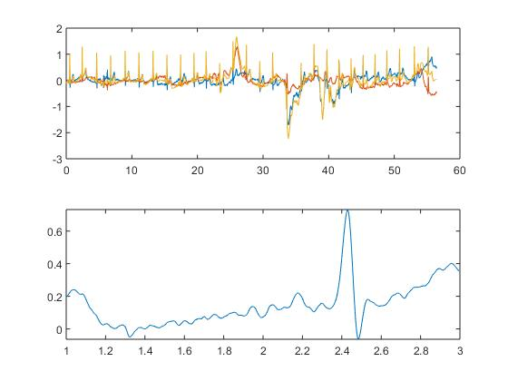

Figure 1.2: Input signal

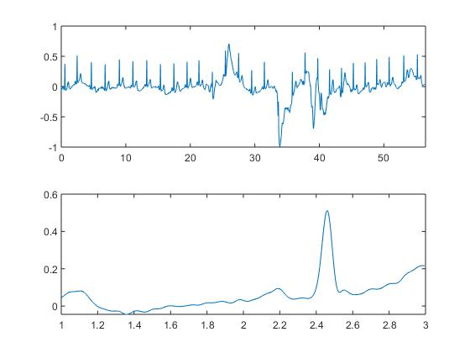

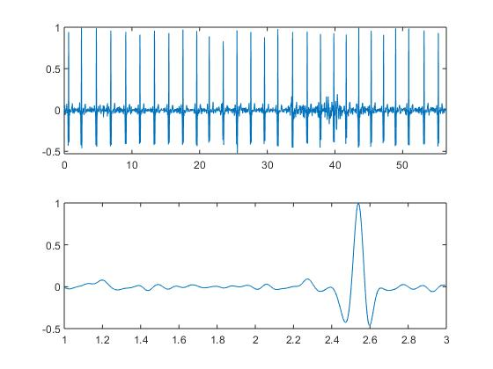

Figure 1.4: Output of High pass filter

Figure 1.3: Output of Low pass filter

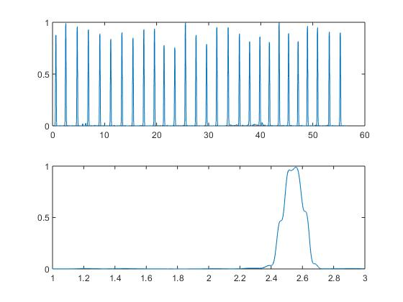

Figure 1.6: Final output

Figure 1.5: Output of last stage

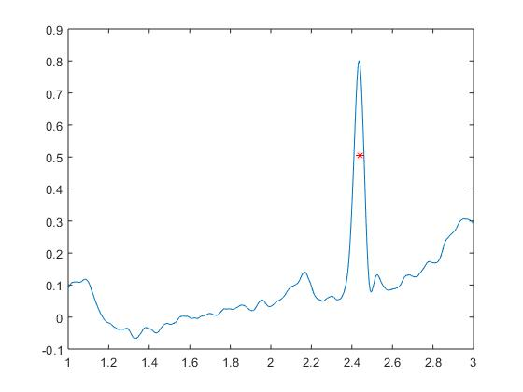

Figure 1.7: Output of High pass filter

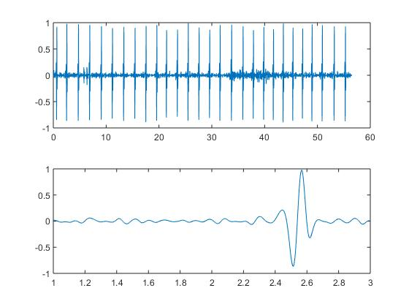

Figure 1.8: Output of squaring stage

